Low Level Design

**Investment Analytics**

|  |  |
| --- | --- |
| **Written By** | Shreyas Patil |
| **Document Version** | 1.2 |
| **Last Revised Date** | 17/03/2023 |

**DOCUMENT CONTROL**

|  |  |  |  |
| --- | --- | --- | --- |
| **Date Issued** | **Version** | **Description** | **Author** |
| **15th March 2023** | 1.0 | Introduction, Problem Statement | Shreyas Patil |
| **16th March 2023** | 1.1 | Dataset Information, Architecture Description | Shreyas Patil |
| **17th March 2023** | 1.2 | Final Revision | Shreyas Patil |

**Contents**

1. Introduction 03
   1. What is Low-Level Design Document? 03
   2. Scope 03
2. Architecture 04
3. Architecture Description 05
   1. Data Description 05
   2. Web Scrapping 05
   3. Data Transformation 06
   4. Data insertion into database 06
   5. Set up the data source 06
   6. Export Data from database 7
   7. Deployment 7

# Introduction

## What is Low-Level design document?

The goal of the LDD or Low-level design document (LLDD) is to give the internal logic design of the actual program code for the House Price Prediction dashboard. LDD describes the class diagrams with the methods and relations between classes and programs specs. It describes the modules so that the programmer can directly code the program from the document.

## Scope

Low-level design (LLD) is a component-level design process that follows a step-by-step refinement process. The process can be used for designing data structures, required software architecture, source code and ultimately, performance algorithms. Overall, the data organization may be defined during requirement analysis and then refined during data design work.

# Architecture

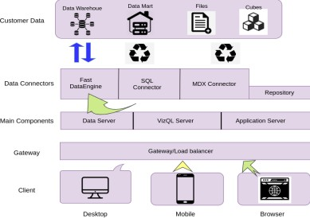

**Tableau Server Architecture**

Tableau has a highly scalable, n-tier client-server architecture that serves mobile clients, web clients and desktop-installed software. Tableau Server architecture supports fast and flexible deployments.

The following diagram shows Tableau Server’s architecture:

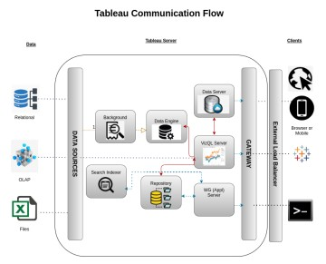

Tableau Server is internally managed by the multiple server processes.

**1. Gateway/Load Balancer**

It acts as an Entry gate to the Tableu Server and also balances the load to the Server if multiple Processes are configured.

1. **Application Server:-**

Application Server processes (wgserver.exe) handle browsing and permissions for the Tableau Server web and mobile interfaces. When a user opens a view in a client device, that user starts a session on Tableau Server. This means that an Application Server thread starts and checks the permissions for that user and that view.

1. **Repository:-**

Tableau Server Repository is a PostgreSQL database that stores server data. This data includes information about Tableau Server users, groups and group assignments, permissions, projects, data sources, and extract metadata and refresh information.

1. **VIZQL Server:-**

Once a view is opened, the client sends a request to the VizQL process (vizqlserver.exe). The VizQL process then sends queries directly to the data source, returning a result set that is rendered as images and presented to the user. Each VizQL Server has its own cache that can be shared across multiple users

1. **Data Engine:-**

It Stores data extracts and answers queries.

1. **Backgrounder:-**

The backgrounder Executes server tasks which includes refreshes scheduled extracts, tasks initiated from tabcmd and manages other background tasks.

1. **Data Server:-**

Data Server Manages connections to Tableau Server data sources

It also maintains metadata from Tableau Desktop, such as calculations, definitions, and groups.

# Architecture Description

## Data Description

To construct a dashboard for FDI data in India from 2000-2001 to 2016-2017, a pivot view of the data was created since the original horizontal format was not suitable for generating effective visualizations in Tableau.

Pivoting data is a common technique in data analysis used to restructure data into a more organized format. In this case, the FDI data was pivoted by years, resulting in a new table where each row represents a single year and each column represents a specific aspect of the FDI data (e.g. FDI inflows, outflows, or net FDI).

This pivot view allows for the creation of different visualizations such as line charts, bar charts, and heat maps to analyze the trends and patterns in FDI over the years. Additionally, filters and drill- downs can be used to explore the data in more detail.

Overall, pivoting data is a powerful technique for organizing and analyzing large datasets, and can lead to more meaningful and insightful visualizations in Tableau.

## Web Scrapping

Web scraping is a technique to automatically extract content and data from websites using bots. It is also known as web data extraction or web harvesting. Web scrapping is made simple now days, many tools are used for web scrapping. Some of python libraries used for web scrapping are Beautiful Soup, Scrapy, Selenium, etc.

## Data Transformation

In the Transformation Process, we will convert our original datasets with other necessary attributes format. And will merge it with the Scrapped dataset.

## Data Insertion into Database

1. Database Creation and connection - Create a database with name passed. If the database is already created, open the connection to the database.
2. Table creation in the database.
3. Insertion of files in the table

## Set up the data source

### Step 1: Configuring Tableau .

To connect with tableau, you will need to provide information about the server which hosts your database. If you want to connect to a contained database, you can also specify the name of the database.

#### Step 2: Configuring Data Source

The data source page loads up after configuring the Tableau connector and successfully signing in.

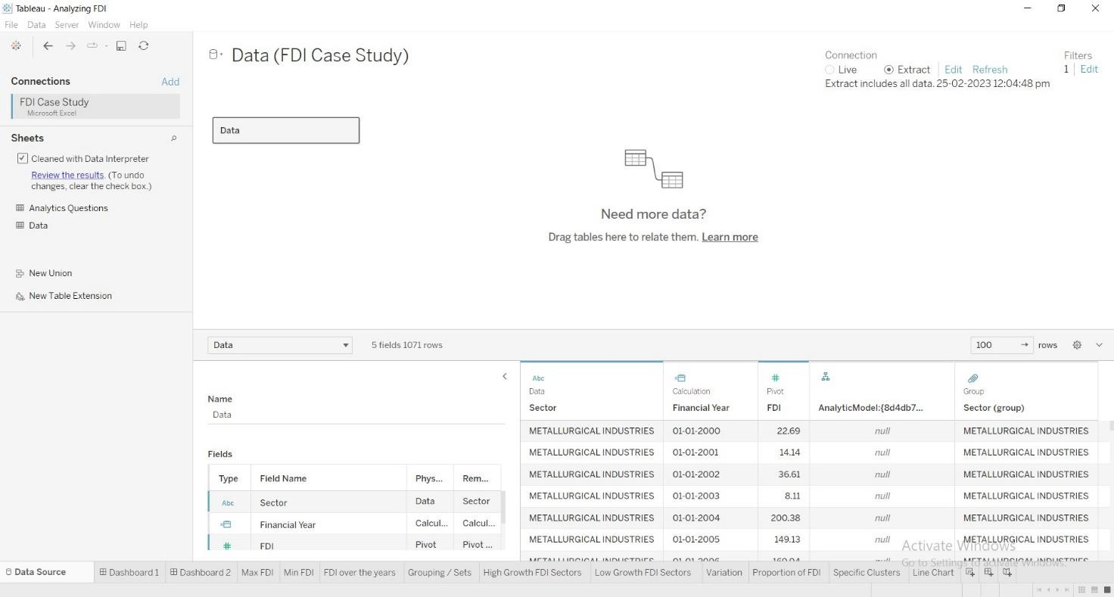

## Export Data from Database

Data Export from Database - The data in a stored database is exported as a CSV file to be used for Data Pre-processing.

## Deployment.

Once you’ve completed your dashboard, follow these steps:**- Server, Tableau Public, Save to Tableau Public As**

#### https://public.tableau.com/app/profile/sarthak.sethi/viz/AnalyzingFDIInVariousSectorsofIndi a_16788217914750/Dashboard1

**DASHBOARD-1**

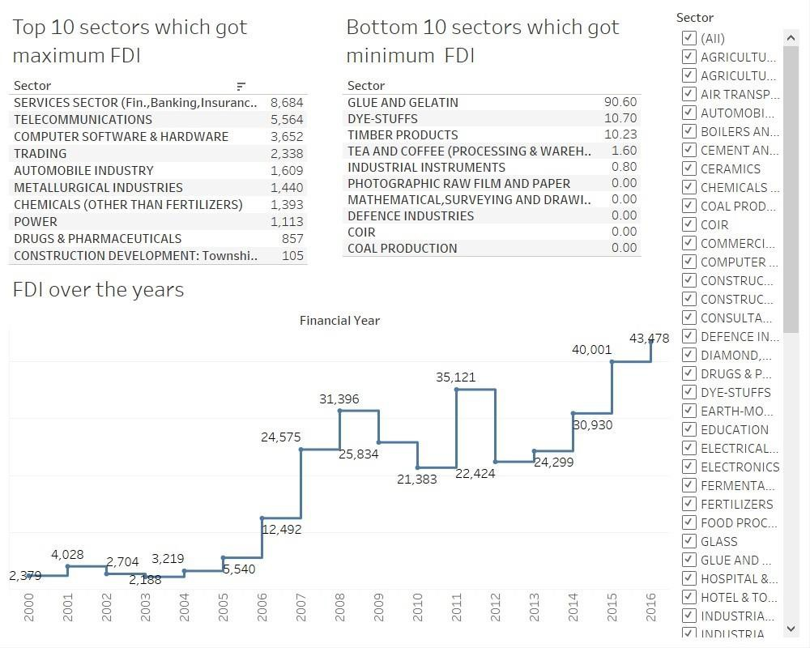

**DASHBOARD-2**

